Insecure Logging

Connect DIVA application using adb

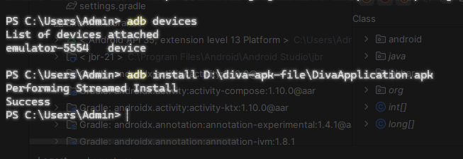

Open DIVA application in the android emulator

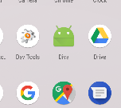

The menu will open for DIVA

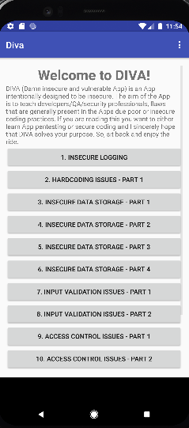

Select Insecure Logging and type any credit card number

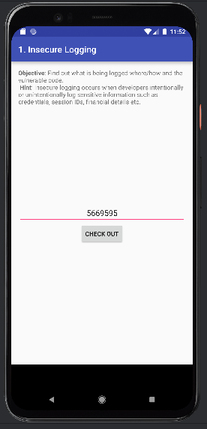

Check Logcat to see if the entered number is captured.

